PseudoCode for MegaDesk project
Dan Crosby
1/23/19

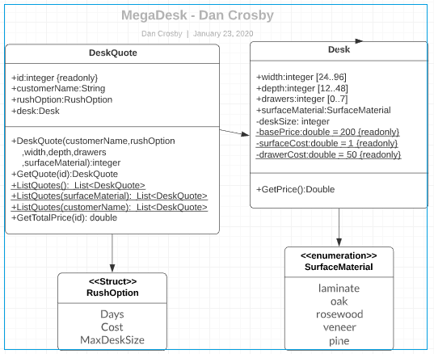

//Program Start

//Initialize GUI
//When variables are entered, GUI will execute the constructor for the DeskQuote object.

// Psuedo code for DeskQuote constructor
Public void DeskQuote(customerName,rushOption ,width,depth,drawers ,surfaceMaterial)
// Instantiate the RushOption structure and populate it with shipping cost table.
// Validate values for customerName, rushOption, width, depth, drawers
// Check the surfaceMaterial value against the enum.
// Instantiate Desk object with width, depth, drawers, surfaceMaterial
End
// Psuedo code for GetQuote(ID) constructor
//Return instance of the DeskQuote objects
//Calling code can read class properties using DeskQuote.customerName, DeskQuote.Desk.width, etc.

// Pseudo code for 3 ListQuotes methods (null, material, or customerName)
//Returns a list of selected DeskQuote objects

// Pseudo code for GetTotalPrice(id)
// Calculate the shipping cost using RushOption
// Return Desk.GetPrice+ shipping cost as Total Price.

// Pseudo code for GetPrice() in the Desk object:
// Calculate total square area and save in deskSize
// Tally costs based on drawer count
// Tally base desk cost
// Tally cost based on surface area
// Tally cost based on surface material
// Return total price as double

